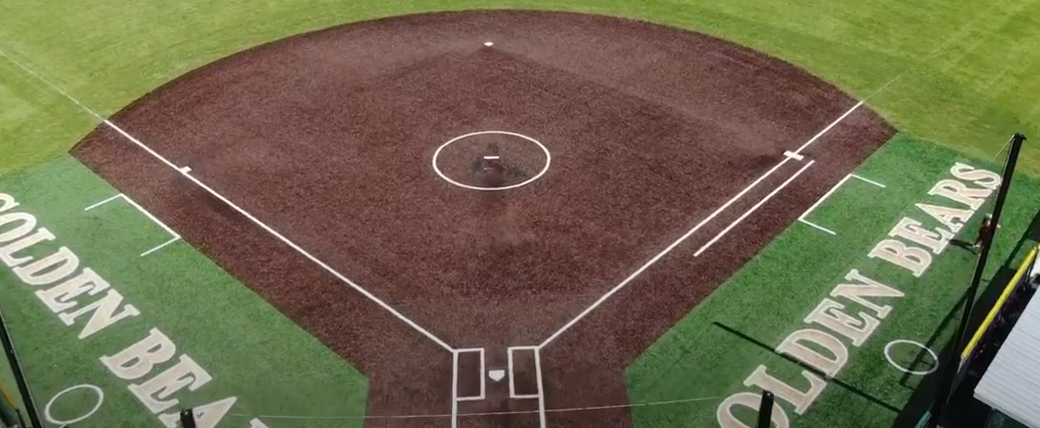

2025 Vestal High School Softball Team Sponsorship

To :

From : Vestal Diamond Committee Jan 10, 2025

Subject: Sponsorship for 2025 Vestal Girls Softball High School Team

## Highlights

* **2024 Class AA Regional Champions**
* **2024 Section IV Champions**
* **2024 Southern Tier Athletic Conference Champions**
* **Our HS Softball program obtains multiple NCAA commitments every year for D1, D2 & D3 schools**.
* **We are a registered 501c3**

We are reaching out on behalf of the 2025 Vestal High School Softball Team. We are very excited about the preparation of the 2025 season and are seeking your support to help make this journey possible for our young athletes. The Vestal High School Softball Team is dedicated to providing opportunities for young girls to excel both on and off the field. Through the discipline and dedication of softball, our athletes learn valuable lessons in resilience, commitment and leadership that will benefit them throughout their lives. However as with any athletic program, financial support is crucial to ensure that all players have the equipment, facilities and training necessary to compete at their best.

This season we are seeking sponsorships from community-minded businesses who share our vision of empowering young women through sports. By sponsoring the Vestal High School Softball Team, you not only contribute to our team’s success but also gain visibility in the community, showing that your company is committed to fostering youth development.

We are offering three levels of sponsorship, Each sponsorship will be added to our highly visited website with a link to your business. All of our social media platforms are also linked to the Softball website in which your business info will display.

We would love to discuss potential ideas on showcasing your business and the support of our girls!

**Sponsorship levels:**

**GOLD: $1,000**

**GREEN: $500**

**GREY: $250**

*If you would like to move forward with obtaining a sponsorship, please respond to this email & we will send over the payment information along with securing your business info for display and our 501c3 letter.*

Thank you in advance for considering this opportunity. Together we can give our athletes an unforgettable season and inspire them to reach their highest potential. Please feel free to reach out with any questions or suggestions.

Sincerely,

[**Joseph Rogan**](mailto:joerogandc@gmail.com)

[***Fundraising Coordinator***](mailto:joerogandc@gmail.com)

[***Vestal Softball Diamond Committee***](mailto:joerogandc@gmail.com)



###### 