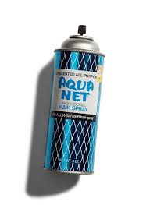
WHITNALL RAGE FASTPITCH ANNUAL 9-PIN TAP
*** 1980’s THEME !!! ***

Sunday December 10th @ 1:30 pm (see below for check in times)
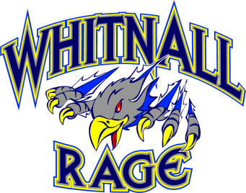
Root River Lanes
7220 W Rawson Avenue
Franklin, WI 53132

Cash Prizes:
1st place bowler in each session- $100
2nd place bowler in each session- $50
Surprise gift for the bowlers with the lowest score in each session
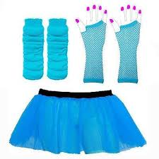
Raffles, Door Prizes, Silent Auction and more

$25/person- 6 person team
*admission includes 3 games, shoe rental, 1 pitcher of soda/beer and 1 pizza per lane

**1:30 pm session should arrive approximately around 1:00 pm to check in

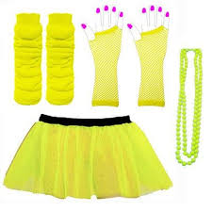
Please detach and return the bottom portion of this flyer, along with a check made payable to Whitnall Rage to: Whitnall Rage
PO Box 178
Hales Corners, WI 53228

You may also register and pay online via the Whitnall Rage website at: www.whitnallragefastpitch.org

QUESTIONS? Whitnallragefastpitch@gmail.com


Bowler(s) Names _ Player sponsor: _____________________ 1:30 am ______

Email address: ___________________________________
(You will receive a confirmation via email that we have received and processed your registration)

